**Screenshots of Module 2 – VBA step by step**

**Ticker and volume**

**Yearly change and percentage**

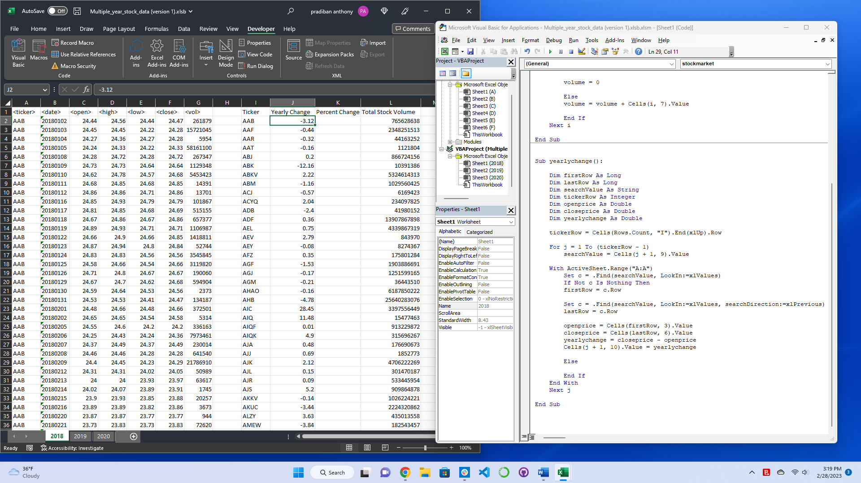

**Yearly change and percentage with formatting**

**Greater Increase and Decrease**

**FINAL with Worksheet Loop**

